Tarek mahmoued abd elhamied
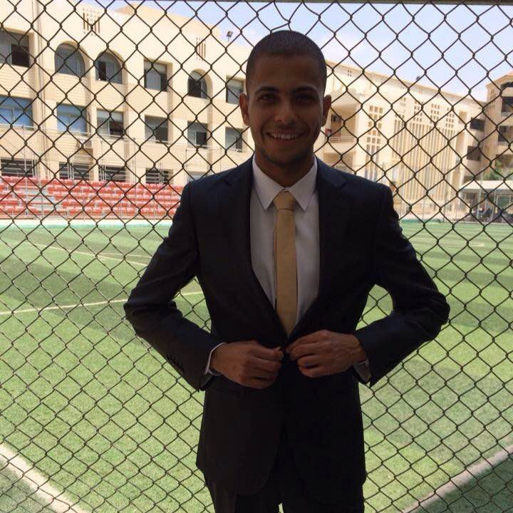
Personal Data :
Date of Birth : 21/2/1993
Address : Cairo-al amirya
Marital Status : Single
Military Service : Served
Nationality : Egyptian
Mobile No. : +2- 01000753943
Religion : Muslim
E-mail : tm37880@gmail.com
Driver License : Private
Qualifications:
Faculty of electrical Engineering – New Cairo Academy (depending of ain shames uni)
Graduation Year : 2014
Distribution
Languages:
Arabic : Mother Tongue
English : Very Good
Skills :
- Hard Working , Able to learn ,search for new ideas in internet to solving problems
- Out going , enjoying meeting new people ,friendly .
- Able to work in any state, can handles under pressure .
- like to work with groups ,able to be team leader
Courses :
- Attended ICDL courses at ain shames uni.
- Electrical Power System distribution basic app .
- Introduction to programmable logic controllers .
- Training of suez oil Company drilling SEP. 2012 .
- Attended English Courses at MODLI till the 10th level
Experience: Working maintenance engineering at el namkay co. for trading &consulting from(1/9/2016)
Till now

